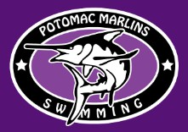
awards

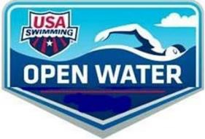
2026 Montclair Swim Festival Saturday May 16, 2026

Lake Montclair in Montclair, VA Hosted by: Potomac Marlins

Register Here:

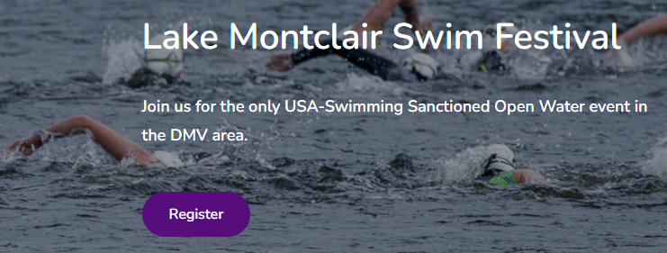

SANCTION | This meet is held under sanctions of USA Swimming Virginia Swimming: VSI-  USA Swimming, Eastern Zone Swimming, Potomac Valley Swimming, Potomac Marlins, Meet Director, Officials, Race organizers, Committee members, Volunteers and Montclair Property Owners  Association shall be held free and harmless from all liabilities or claims for damages arising because of injuries to anyone during the conduct of this event.
Hosted by | Potomac Marlins
Location | Dolphin Beach: 4398 Spillway Lane. Montclair, VA 22025 Parking for event: (please see pg 6)  Water Quality Information: Attached you’ll find last year’s test results completed by the  MPOA. https://www.montclairva.com/single-post/mpoa-weekly-update-may-23-2025  Changing into or out of swimsuits other than in locker rooms or other designated areas is prohibited.  Meet Management may restrict access to specific competition areas, including the start, competition course, and finish areas. Only athletes, coaches, officials, and official meet staff actively participating in the meet shall be permitted in these areas. All coaches must present a valid USA Swimming coach card to the Meet Director prior to the commencement of any sanctioned swim meet, and must have this card with them to enter restricted areas of the race venue.
Spectator Admission | Admission is free. We ask that swimmers/spectators come no more than 1 hour ahead of race start to reduce traffic. All swimmers/spectators must exit within 30 mins of  awards.
Event Staff | Meet Director: Christine Haslem christine.haslem@gmail.com  Co-meet director: Ryan Krogel ryan.krogel12@gmail.com  Referee: Andrea Kelley bandkell@aol.com  Entry Chair: Reid Owen reid.owen@gmail.com  Course Referee: Garrett Haslem  Admin Official: Jeff Chu jeff@hauppaugeswimming.com  Independent Safety Monitor: Randy Cooper randycooper@thestjames.com  Medical Officer: Alysen Spencer
Timing System | Pace clock and video system.
Eligibility | Open to all USA Swimming member athletes registered prior to first day of the meet.  - Must be a registered USA Swimming athlete to enter.  - A one-day PVS Swimming/USA Swimming Membership registration is available for this event. It is $15 for those not already registered through USA swimming. It MUST be completed 1-3 days prior to event day. No event-day USA/PVS Swimming registrations will be permitted.  - Age on May 16, 2026 will determine age for the meet.

Recommended entry standards:
- For 12 and under events, Minimum of BB time standard in the 500yd freestyle or the 400M freestyle or successfully completed a minimum of a 500M open water swim in a bay, river, lake or ocean.
- For 13 - 14 and 15-18 events: Minimum of an BB time standard in the 1000yd, 1650yd, 800M, or 1500M freestyle or successfully completed a minimum of 1K open water in a bay, river, lake or ocean.
- For Senior/Open Event: Minimum of a BB time standard in the 1000yd, 1650yd, 800M, or 1500M freestyle for 15-18 Age Group or successfully completed a minimum of a 2K+ open water in a bay, river, lake or ocean.
Individual Competition | The following events will be offered:  - 5K: (double loop course)  Age Groups: Open, 15-18, 13-14  - 2.5K: (single loop course)  Age Groups: Open, 15-18, 13-14, 11-12  - 1.5K: (double loop course)  Age Groups: Open, 15-18, 13-14, 11-12  - 750 M: (single loop course)  Age Groups: Open, 15-18, 13-14, 11-12, 9-10
COURSE DESCRIPTION | This is an open freshwater lake swim. The weather and water conditions are unpredictable; please use good judgment if you are uncertain about swimming in open water.  The 5K should NOT be an athlete’s first open water experience.  The course is set; however, the race committee reserves the right to change the configuration and/or direction of each event due to race day conditions. The details of races with landmarks are attached. Any questions about the course will be addressed at the pre-race meeting.  The water temperature is expected to be in the range of 68 – 75 F. At any sanctioned open water competition with a race distance of 5k and greater, USA Swimming rules regarding use of wetsuits shall apply.
 | Meet Day Information
Check-In | Swimmers must report to the check-in table for packet pick up and report to the meet officials that they are present and prepared to swim. At that time, the swimmers will receive instructions for the competition deemed necessary.  5K & 2.5K Championship  - RACE REQUIRES Check-In between 7:45 AM-8:30 AM (participation may be revoked without refund if late to registration)  - Warmups are 8:00 AM-8:30 AM  - Pre-Race Briefing Mandatory will be held at 8:45 AM at the start of the racecourse.  1.5 k Championship  - RACES REQUIRE Check-In between 11:15 AM-12:00 PM (participation may be revoked without refund if late to registration).  - Pre-Race Briefing Mandatory will be held at 12:15 PM at the start of the racecourse.  750M Championship  - RACES REQUIRE Check-In between 12:30-1:15 PM (participation may be revoked without refund if late to registration).  - Pre-Race Briefing Mandatory will be held at 1:15 PM at the start of the racecourse.  Schedules and wave assignments are subject to change depending on number of entries and local conditions.

Marking | Prior to the start, swimmers shall be marked with their race numbers on both upper arms and their upper caps. The swimmers shall be numbered vertically down the arms and horizontally across the caps. They will possibly also be numbered horizontally on backs or hands. This will take place at registration. Swimmers will get tattoos, caps, in their information packets on race day.
WARM-UP PROCEDURE | Warm-up will be available on the portion of the racecourse closest to the finish area. 8:00 AM-8:30 AM for 5K /2.5K participants only.  No warm-downs will be offered.
Start/Finish | The races will take place in waves 2-5 mins apart for additional safety to the swimmers. All races will begin and end at Dolphin Beach shoreline and will finish with a slight run to finish line on the beach.
Time Limits | Athletes not completing the 5K within 2 hours may be removed from the course at the decision of the Meet Referee.
Safety Conditions | If the swimming conditions are not deemed safe (water quality, dangerous weather, debris, etc.), the meet may be canceled. This decision will be made by May 15th 11 am and will be posted to the Potomac Marlins website https://www.potomacmarlins.com/page/home. Inclement weather for a portion of the weekend: if a storms approaches, the meet director may delay the meet until it passes so that all athletes and spectators are safe. Additionally, the meet may be delayed if the weather conditions are below the minimal temperatures and a delay will offer warmer conditions.
Escort Safety Craft | Coaches, or personnel requested by a swimmer, are not allowed on the lake with any escort safety craft. The Meet Referee, Meet Director, Entry Chair, or Lifeguards only may designate who is on the course at any given time.
SAFETY PROCEDURES | There will be a mandatory Pre-Race Briefing held 15 minutes before competition begins to discuss the course, rules and safety procedures. The Referee will remove any swimmer from competition who does not attend the pre-race briefing or is found to be inattentive during the briefing. Course will be patrolled by qualified safety personnel. For safety reasons, participants should be adequately trained for open water competition. Lifeguards reserve the right to remove any swimmer from the course if the swimmer appears in imminent danger. Previous open water experience is recommended. Safety watercrafts, lifeguards, and officials on paddleboards /kayaks will monitor the entire course. Swimmers must wear body-marked race numbers on arms and caps for identification.  The following have the authority to independently pull the sanction (stop the meet) at any time for safety reasons: Christine Haslem,-Meet Director, Andrea Kelley-Meet Referee, Randy Cooper Safety Director.  - Finger and Toenails should be neatly trimmed and not extend past the finger/toe, to prevent injury to others. Race Officials may require nail trimming to compete. Determined at race day check-in.  - No shaving is permitted at the competition site.  - No glass containers are permitted within the facility.  - Swimmers (Under 18) must be under the supervision of a coach. If a swimmer arrives at the meet without a coach, the swimmer should notify the referee before he/she warms up. The referee will assign the swimmer to a registered coach for warm-ups.
Medical Facility | Prince William County Fire & Rescue will have 1 ambulance and 1 skiff to provide medical attention to any athlete or spectator in need. Should additional attention be needed, the medical staff will take the patient to the closest medical facility. The medical officer will communicate which facility to emergency contact.
 | Safe Sport
MAAP & ATP  Requirements | All applicable adults participating in or associated with this meet, acknowledge that they are subject to the provisions of the USA Swimming Minor Athlete Abuse Prevention Policy (“MAAPP”), and that they understand that compliance with the MAAPP policy is a condition of participation in the conduct of this  competition.

Image Authorization | All participants agree to be filmed and photographed by the official photographer(s) and network(s) of USA Swimming under the conditions authored by USA Swimming, and allow event organizers the right to use names, pictures, likenesses, and biographical information before, during or after the period of participation in USA Swimming competitions to promote such competitions  PHOTOGRAPHY AND VIDEO RECORDING:  Meet Management has the full authority to restrict any and all photography and visual recording at the event by spectators. Photography or video recording (using cameras, video cameras, iPads, cell phones, etc) is prohibited in any “Non-Camera Zones” as designated by Meet Management.  Any individual failing to abide by these rules may be ejected from the facility and be subject to a Code of Conduct violation at the discretion of Meet Management.  DRONES: Operation of a drone, or any other flying apparatus, is prohibited over the venue (pools, athlete/coach areas, spectator areas and open ceiling locker rooms) any time athletes, coaches, officials and/or spectators are present. Exceptions may be granted with prior written approval by the USA Swimming Vice President of Program Operations.
Facility & Changing Areas | Lake Montclair is a 108 acre lake situated in Montclair, VA.  Dolphin Beach, 4398 Spillway Lane Montclair, VA 22025  Changing into or out of swimsuits other than in locker rooms or other designated areas is prohibited.  Meet Management may restrict access to specific competition areas, including the start, competition course, and finish areas. Only athletes, coaches, officials, and official meet staff actively participating in the meet shall be permitted in these areas. All coaches must present a valid USA Swimming deck pass to the Meet Director prior to the commencement of any sanctioned swim meet and must have this pass with them to enter restricted areas of the race venue.
 | Scoring and Awards
Scoring | The meet will not be scored.
Awards | AWARDS:  5K Awards:  Overall winner for Male & Female  Age Group Awards: 1st-3rd Place Male and Female in each of the following age groups 13-14, 15-18, Open  2.5K Awards:  Overall winner for Male & Female  Age Group Awards: 1st-3rd Place Male and Female in each of the following age groups: (11-12, 13-14, 15-18, Open)  1.5K Awards:  Overall winner for Male & Female  Age Group Awards: 1st-3rd Place Male and Female in each of the following age groups: (11-12, 13-14, 15-18, Open)  750 m AWARDS:  Overall winner for Male & Female  Age Group Awards: 1st-3rd place Male and Female in the following age groups: 9-10, 11-12, 13-14, 15-18, Open  All participants will receive a Montclair Swim Festival bag tag.  *Awards are subject to change based on the number of participants in each category.

Course Format  (See Race Schedule For Wave Information) | 5K  (13 & Over) | The 5K race will be a 2.5 K double loop. (see 2.5K/5K map below). Athletes will start at the edge of the water on Dolphin Beach. The swim is planned for a counter clockwise swim on the outside of the turn buoys (buoys to the swimmer’s  left). The finish will be a beach finish. Athletes not completing the 5K within 2 hours may be removed from the course at the discretion of Meet Management.
Course Format  (See Race Schedule For Wave Information) | 2.5K  (11-12; 13-14,  15-18, 19 & O) | The 2.5K race will be a 2.5K single loop (see 2.5K/5K map below). Athletes will start at the edge of the water on the Dolphin beach. The swim is planned for a  counter clockwise swim on the outside of the turn buoys (buoys to the swimmer’s left). The finish will be a beach finish at Dolphin Beach.
Course Format  (See Race Schedule For Wave Information) | 1.5 K  (11-12, 13-14, 15-18, 19 & O) | The 1.5K will be a 750m double loop (see map below). Athletes will start on the beach at the edge of the water on the Dolphin beach. Swimmers will turn left at  the first buoy and left again at the remaining buoys. The finish will be at Dolphin Beach.
Course Format  (See Race Schedule For Wave Information) | 750m Triathlon prep  (9-10, 11-12, 13-14, 15-18,  19 & O) | 750m race will be a single, 4 buoy rectangular loop of approximately 750 meters. Athletes will start on the beach at the edge of the water on the Dolphin beach. Swimmers will turn left at the first buoy and left again at the remaining buoys to a beach finish at Dolphin Beach.
Team Entries | No team entries will be accepted. Coaches, please direct swimmers to enter online.
Individual Entries | 2 events per person (Either the 5 or 2.5K and the 1.5K or the 750m)  NO ON-SITE OR SAME DAY MEMBERSHIP REGISTRATION WILL BE PERMITTED!  Individual swimmers can register online through:  Entry Link Here  A one day PVS Swimming/USA Swimming registration is available for this event but MUST be completed prior to event day. The 1-day registration form will be available 3 days prior to event (link sent via email) and must be completed to participate in this USA-S sanctioned event.
Entry & Registration Fees | USA Swimming Members: $95.00 for 5K and $80 2.5K  USA Swimming Members: $70.00 for 1.5K and $60 for 750 m  DOUBLE DOG DARE CHALLENGE: This is new this year. By doing the 5K & 1.5K swims ($150 entry) you’ll get an additional unique medal for completing both. Information is coming soon.  Non-USA Swimming members are required to purchase a One-day ($15) membership in advance of the event and must register through Potomac Valley Swimming.  Residents of Montclair will receive a $10 off discount. Please email the race director for discount code.  No refunds will be given.  Price increases $10 for each event after 1/1, 3/1 and 4/1 if space available.  All meet fee payments must be received by 11:59 PM on 05/08/26.
Athlete Attitude | Athlete conduct will be governed by Part Seven of the USA Swimming Rules and Regulations Handbook. Intentional obstruction, interference or intentional contact with another swimmer may be deemed "Unsporting Impedance" and lead to disqualification. Swimmers shall maintain clearance from other swimmers except at the start, turn, and the finish or where the course or race conditions dictate otherwise. Parents and swimmers should be advised there are a significant number of entrants, open water swimming may be expected to involve inadvertent contact with other swimmers. It is important that swimmers  keep a cool head while in the water.
RULES | Current USA Swimming Rules and Regulations will govern this event. Please see Part Seven of the USA Swimming Rules & Regulations for complete list of Open Water Rules.  - Any swimmer not turning properly at the buoys will be asked to return to the buoy to take the turn properly. Failure to do so will result in the swimmer being disqualified.  - No swimmer shall be allowed to use or wear any device that may be an aid to his/her speed, endurance, or buoyancy.  - A maximum of two (2) caps may be used.  - World Aquatics rules for swimwear will be used for all events  - USA Swimming athlete members must be under the supervision of a USA Swimming member coach during warm-up, competition, and warm- down.

LIABILITY | Liability USA Swimming, the LSC, the venue, and the host organization shall accept no responsibility for liability or injuries sustained by any individual, athlete, coach, official, meet volunteer, or spectator while traveling to and from or while participating in these events. Damage to the venue, when proved, will cause the offending participant, if unattached, or the offending swimmer's club, if attached, to be held accountable for repairs. All participants and guests must adhere to all rules and coaches must supervise their swimmers at all times. Children must be supervised at all times.
Swimwear | No swimmer shall be allowed to use or wear any device that may be an aid to his/her speed, endurance, or buoyancy. A maximum of two (2) caps may be used. Swimwear must conform to USA Swimming Rule 701.4. Only swimsuits complying with World Aquatics Open Water swimsuit specifications may be worn in any USA Swimming sanctioned or approved competition.  Meet Directors may also designate a wetsuit competition category at any event other than Junior National Championships, National Championships, and Zone Open Water Championships. Wetsuits (for both men and women) shall not extend beyond the next, wrists, and ankles. The thickness of material(s) used shall be maximum 5 mm. This event will likely be wetsuit legal based on the previous year’s combined air and water temperatures.
Programs | Programs will not be provided. An entry list will be provided via email 1 week prior to the event.
Final Results | Final results will be posted to https://www.pvswim.org/openwater.html
Refreshments | Coaches and Officials will be provided with hospitality. Athletes will have a banana and bottled water at the finish line available. A food truck will be available for any additional purchases.
Parking | Parking on-site is only available to officials and volunteers. If you are disable and planning to spectate, please email the meet director to reserve a space on-site. Christine.haslem@gmail.com  Parking is available for participants/spectators:  Moncure Park (0.2 mile walk) 4433 Waterway Dr, Montclair, VA 22025  or at Pattie Elementary School (0.6 mile walk via walking path behind school): 16125 Dumfries Rd, Dumfries, VA 22025
Officials and Volunteers | Open Water Officials with certification card are welcomed and encouraged to assist. Please complete the form: For further inquiries please contact Andrea Kelley at bandkell@aol.com  Each USA-S team entering athletes is required to provide one adult volunteer to help with the event. Participating clubs will be notified of work assignments by the Monday before the meet. Additional volunteers are welcome and encouraged. Please contact the Meet Director.
Lodging | Holiday Inn Express Dumfries  3901 Fettler Park Dr, Dumfries, VA 22026•(703) 441-9001  Hilton Garden Inn Woodbridge  2500 Neabsco Common Pl, Woodbridge, VA 22191•(703) 590-2500  Country Inn & Suites by Radisson, Potomac Mills Woodbridge, VA 2621 Prince William Pkwy, Woodbridge, VA 22192•(703) 496-4596  Courtyard by Marriott Potomac Mills Woodbridge  14300 Crossing Pl, Woodbridge, VA 22192• (703) 491-4525

RACE SCHEDULE
Schedules and wave assignments are subject to change depending on number of entries and local conditions.

Race Schedule
5K
Wave 1: 9:00 AM Male Swimmers Ages 13 & O
Wave 2: 9:05 AM Female Swimmers Ages 13 & O

2.5K
Wave 1: 9:10 AM Male Swimmers Ages 13-14, 15-18 & 19 & O
Wave 2: 9:15 AM Female Swimmers Ages 13-14, 15-18 19 & O Wave 3: 9:20 AM Male & Female Swimmers Ages 11-12

1.5K
Wave 1: 12:30 PM start for all Male Swimmers Ages 13-14, 15-18, 19& O Wave 2: 12:35 PM start for all Female Swimmers Ages 13-14, 15-18, 19& O Wave 3: 12:37 PM start for all Male & Female Swimmers Ages 9-12

750M
Wave 1: 1:30 PM start for all Male Swimmers Ages 13-14, 15-18, 19& O
Wave 2: 1:35 PM start for all Female Swimmers Ages 13-14, 15-18, 19& O
Wave 3: 1:37 PM start for all Male & Female Swimmers Ages 9-12

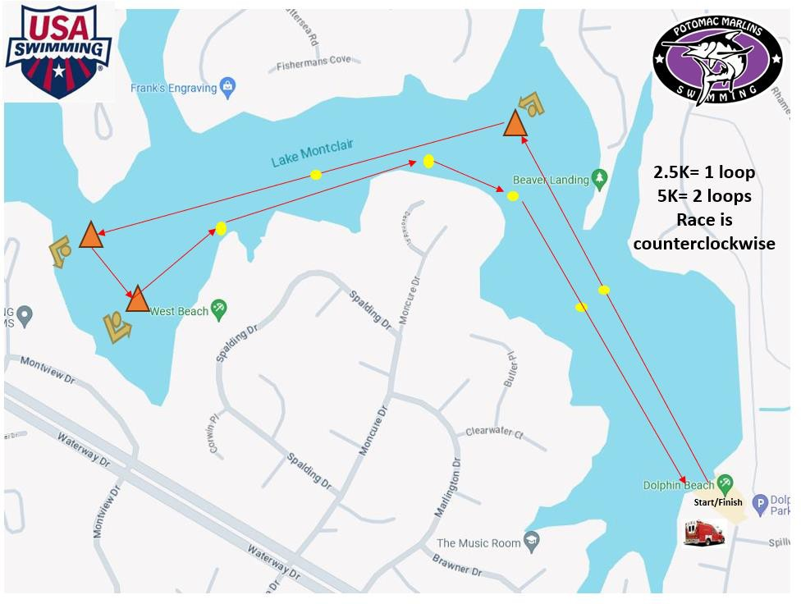
RACE MAPS 5K/2.5K
1.5K/750m
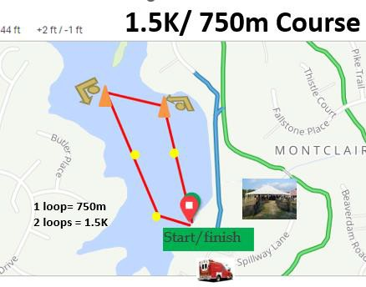

Release and hold Harmless Agreement
In consideration of being permitted to participate in this swim meet, and for other good and valuable consideration, the undersigned, for himself, his successors and assigns, hereby releases and forever discharges Potomac Marlins, PVS, and its Board of Directors, USA Swimming Inc., Montclair MPOA and each of their respective officers, agents, employees, members, successors, and any other persons in any way connected with this meet, form any and all liabilities, claims, demands, actions, or causes of action of whatever kind of character arising out of or in connection with said event.
Further, the undersigned shall indemnify and hold harmless Potomac Marlins and PVS, USA Swimming Inc., Montclair MPOA and the officers, trustees, agents, employees, and members of the foregoing and all other persons in any way and claims arising out of or in connection with any injury, including death, or alleged injury of damage to property sustained or alleged to have sustained in connection with or to have arisen out of said event.

When entering this event, you are acknowledging this wavier of liability.

*Prices will increase $10/event/swimmer on 1/1/26, 3/1/26, 4/1/26 (if space available). Register early to save money. Shirts will not be guaranteed if registered after 3/31/26. No entrant will be permitted to compete unless the entrant is a member as provided in Article 302
Held under the sanction of USA Swimming

